**Fixed Asset Automation**

This document summarizes the setup of automating the creation of Fixed Assets with the creation of Vendor Bill/ Journal entries. When a vendor bill/journal creates corresponding fixed asset records will be created automatically. If the count of lines that can have a Fixed Asset Record, is greater than 100, then the Fixed asset creation will be scheduled and it will be executed every hour.

We’ve used a User event script, client script and a Scheduled script for the process. If the number of lines are below 100, the User event script will trigger and otherwise, the schedule script will execute. The Schedule script will execute on every hour. The client script is used for the validations.

**Vendor Bill**

To create vendor bill, go through following navigation **Transactions > Payables > Enter Bills.** To create vendor bill, need to provide vendor name first. Because, this record is bit slow to load. After providing the vendor name, provide Reference number.

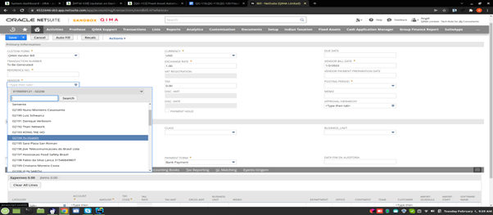

There are 2 subsists are available; Expense and Item.

On the Expense line, there is an account field on the expense line. On the account list, **Fixed Asset** type account should be selected. Because fixed assets can be created from this type of account. Ie; fixed assets can be created only if the account type is Fixed Asset. Each account may/ mayn’t have an asset type. To list the asset types, there will be a custom line field **Asset Type** and this lists asset type according to the selected account. Some accounts mayn’t have asset types. Using such accounts, we can’t create a fixed asset. So, that lines need to be excluded. For this purpose, there is a custom line level checkbox field is available **Exclude Asset type**. If this is checked, fixed asset won’t be created from that particular line.

Major validations on this section are;

* Can’t create Fixed Asset without Asset Types
* Can’t create Fixed Asset by checking the **Exclude Asset type** checkbox
* Can’t edit a line that already has a fixed asset

You can provide all the details like this on both the Expense and Item lines. After providing this save the record. If the total number of lines (ie; the number of expense lines + the number of item lines) is below 100, fixed assets will be created in Realtime, otherwise, that will be created by scheduling. For this we are using a custom record **FAM Asset**. Using this, the scheduling process will be executed. After creating fixed assets, the reference of the fixed asset will be listed on each lines of Vendor Bill. A custom line field **Related Asset** is used for this. This field can’t be edited.

Likewise, the user could edit already existing vendor bills. They could only add more lines to the bill. They can’t edit the line that has related assets. Ie; the user can’t edit the lines, that already have fixed assets. Users could copy an existing vendor bill. But while copying, the values of the filed **Related Asset** and **Asset Type** will be cleared and the checkbox **Exclude Asset type** will be unchecked. If the user needs to create a fixed asset for this line, they need to uncheck the checkbox and provide the Asset type.

**Journal**

Like the Vendor bill, we could create fixed asset for Journals. To create a journal, follow the navigation **Transactions > Financials > Make Adjustment Entries.** In the journal also, there 3 contexts are available for the Fixed asset creation. Ie; Create, edit and copy. All the process are same as on the Vendor bills. But the difference is that journal has **Credit** lines and **Debit** lines. Here, user could create fixed asset from the Debit lines only. If the credit line asset type also, it won’t create fixed asset from credit line. Another important point is that, Afterall the journal should be balanced. Ie; the amount on the credit side and debit side must be equal.

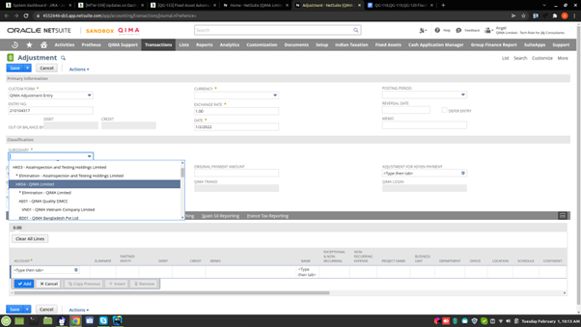

**Fixed Asset Records**

To store the fixed asset that are created from either vendor bill/ journal we are using a custom record **FAM Asset.** This record can be viewed from Vendor bill/journal.

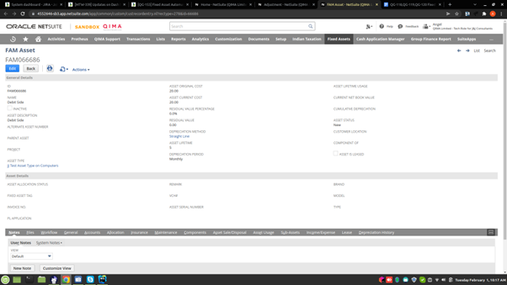

In the **General** subtab, there is a field **Parent Transaction,** this holds the reference to the corresponding Vendor bill/ Journal of the Fixed asset record. User could see from which line, this particular fixed asset record is created.

Following are the steps to create fixed asset from vendor bill.

1. Transactions > Payables > Enter Bills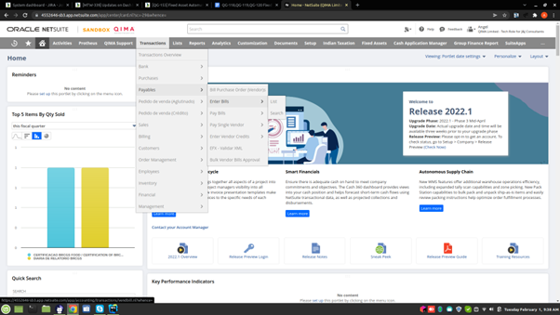
2. Select ‘Vendor’ First ( Loading the record is bit slow)



Enter Reference Number After loading all the items in the subtab

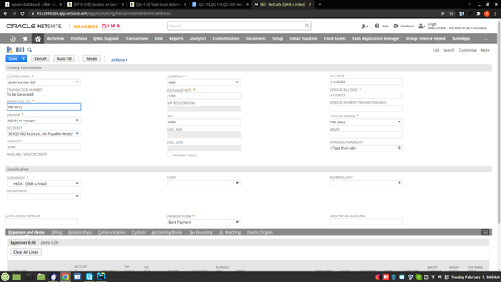

Adding Expense line fields (Account)

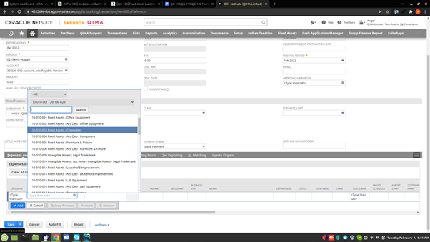

Adding Expense line fields (Amount)

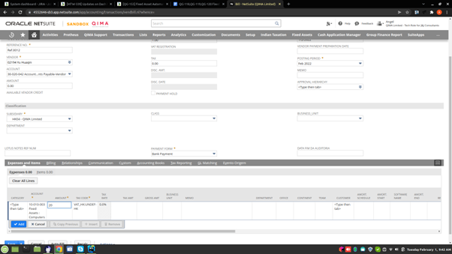

Adding Expense line fields (Memo)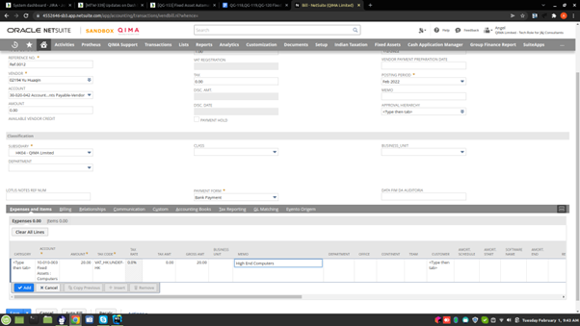

Adding Expense line fields (Asset Type)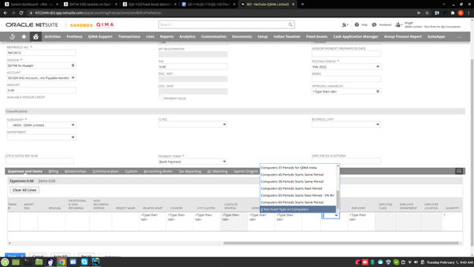

Adding Expense line fields (Employee, If Necessary)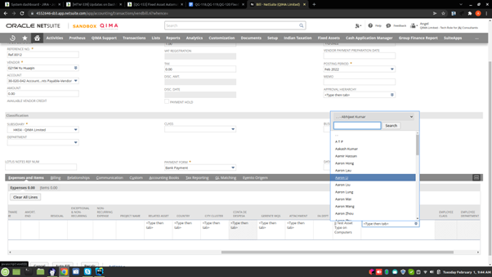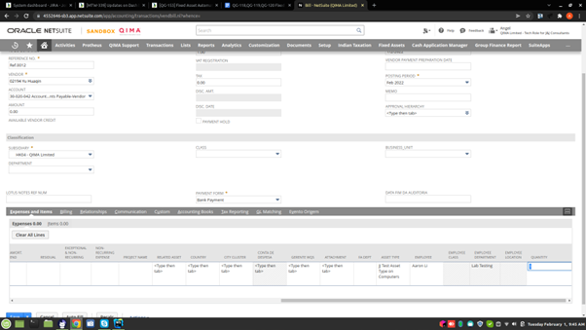

Adding Expense line fields (Quantity)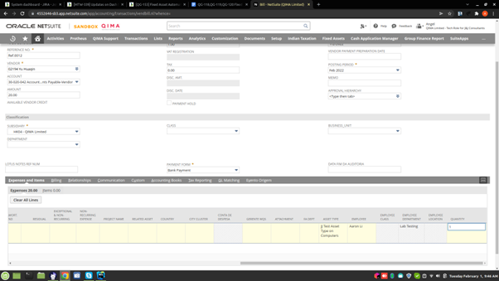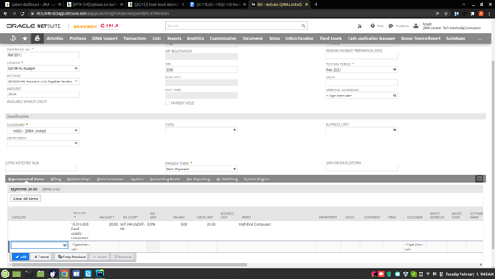

Adding Item line fields (Item)

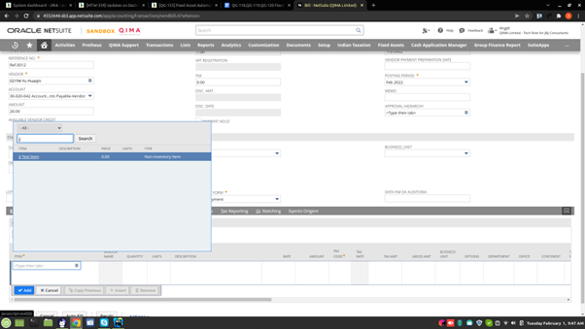

Adding Item line fields (Asset Type)

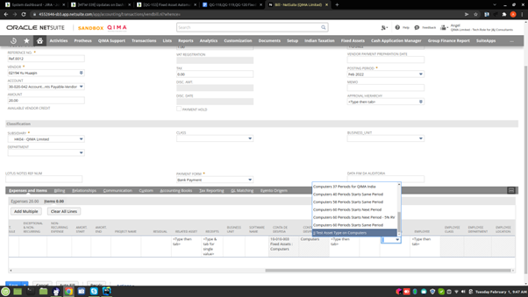

Adding Item line fields (Employee , If necessary)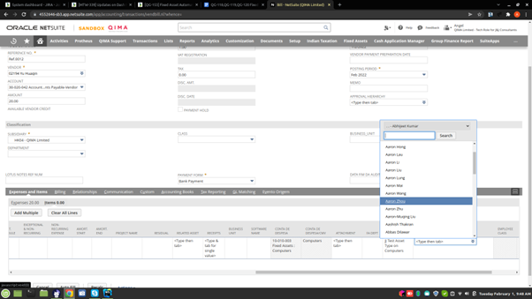

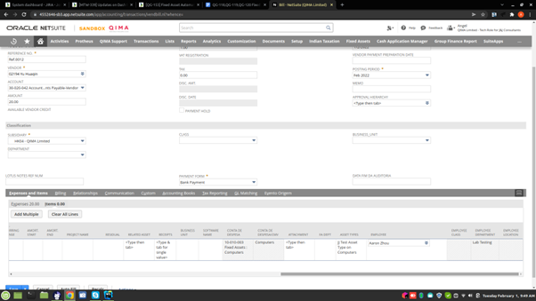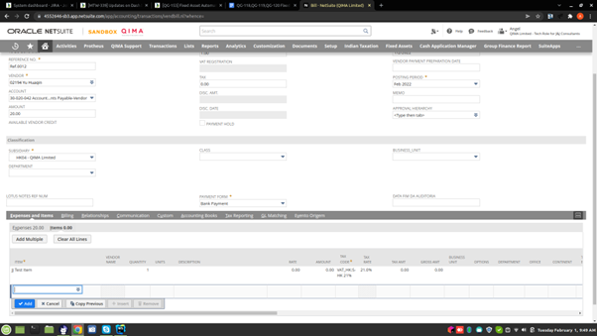

1. Click Save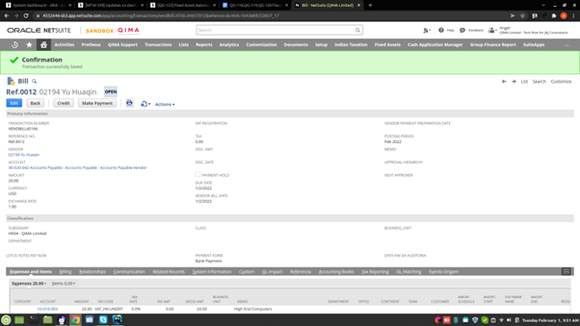
2. By clicking on the related asset, You will guide to the created fixed asset record

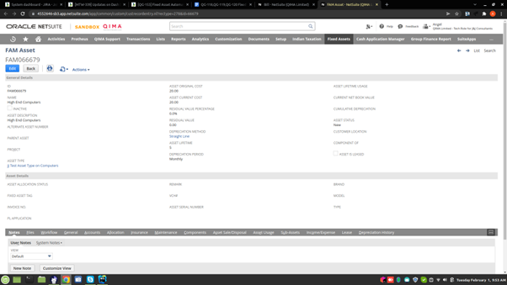

1. On clicking ‘General’ subtab, You can view subsidiary, employee and employee details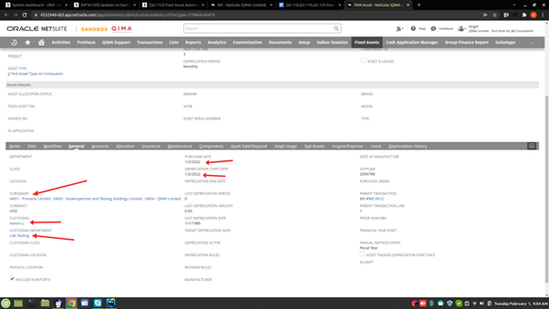
2. On clicking ‘General’ subtab, You can view the reference to the vendor bill which the fixed asset created from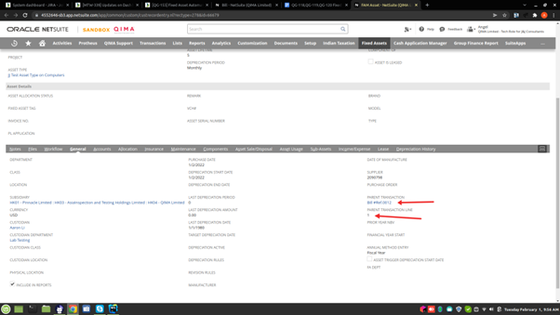
3. On clicking ‘Maintenance’ subtab, You can view the quantity of the item from the vendor bill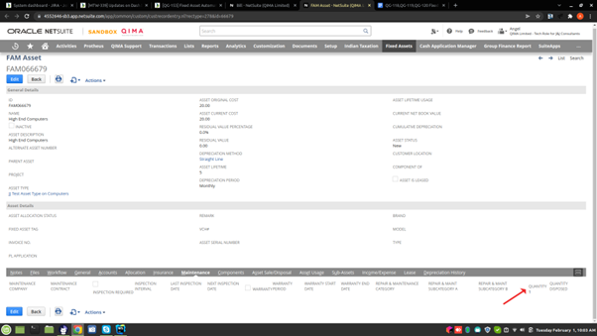

**Steps for scheduled creation of Fixed assets**

1. Create / Edit the lines of journal/ vendor as per the above mentioned steps

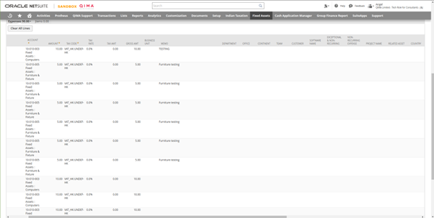

There won’t be any related asset in the list because it has more lines than the limit

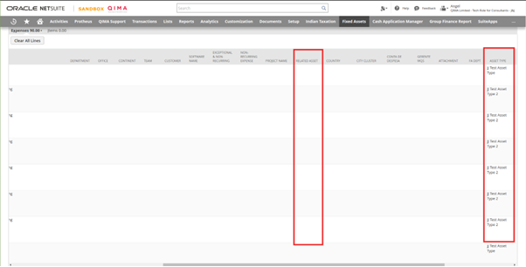

1. After Adding all details Save the record

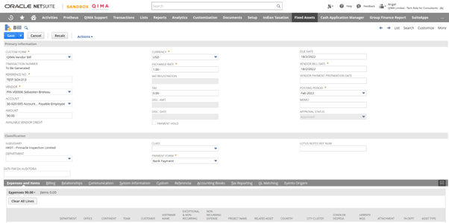

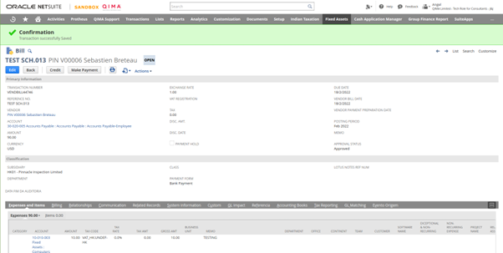

1. Refresh the page and you can view related records in each line by refreshing the page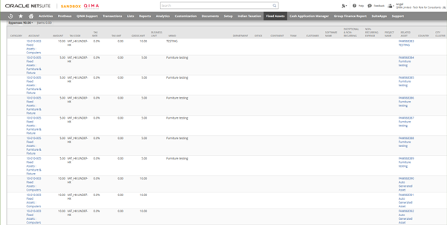

**Risks & Notes**

* When creating vendor bills, avoid creating entries which has location Brazil. There is a permission issue regarding those entries
* In the update, all the Asset types are validating according to respectives subsidiaries and account. Ie; the selected asset type’s subsidiary and account and bill/journal’s subsidiary and account should be the same. Subsidiary field in Asset type is newly added field. So currently there are 2-3 asset types that have subsidiaries.
* In the Update, there are 3 transaction line fields added in bill and journal, which are Employee class, Employee department and Employee location. These 3 fields are disabled fields. When the employee is selected, that particular employee’s class, department and location will be stored in these fields
* In the case of bill, if you want to check/view the subsidiary of selected asset type, click on the field in Edit context, then there will be a symbol which indicates external tab, click on the button then you will go to the corresponding asset type’s record. You can see the subsidiary on that record. If you want to see it’s account type, go to ‘Accounts’ sub tab on the same record and in that check the value in the field ‘asset account’
* In the case of journal entries, Do the same as above and if you want to see the account, check with ‘Expenses account’
* In the New update There are 3 fields added in the Fixed asset record which are, Custodian Department, Custodian Class and Custodian location. Employee department, location, and class will be stored in the above mentioned 3 new fields
* when you select an employee, if the employee has an inactive department or class it will alert and you have to select another Employee